**Components of iNail Pro**

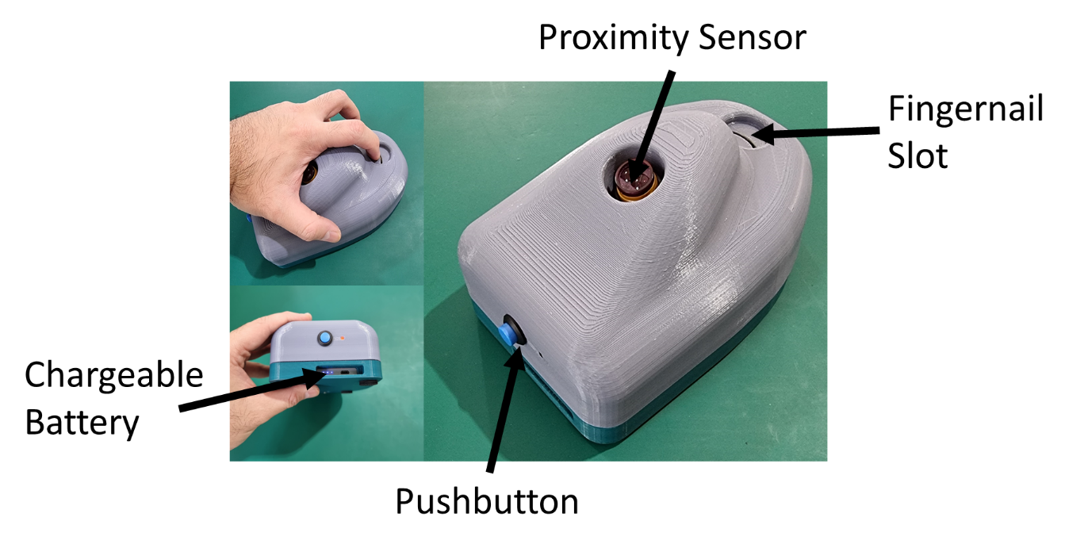

**Instruction Manual**

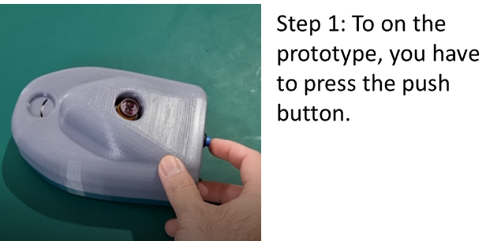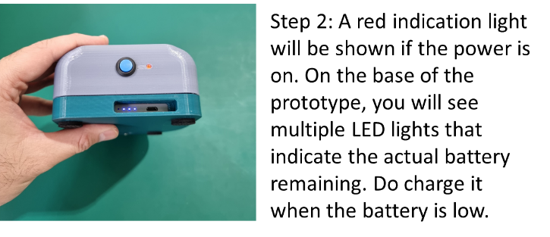

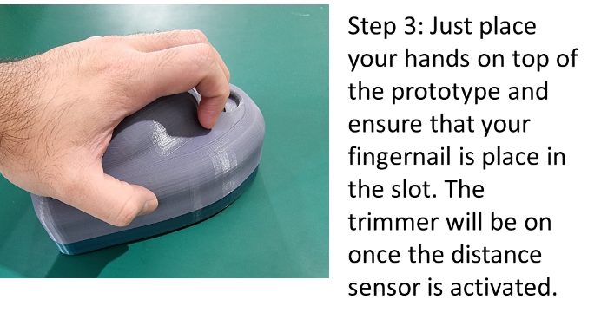 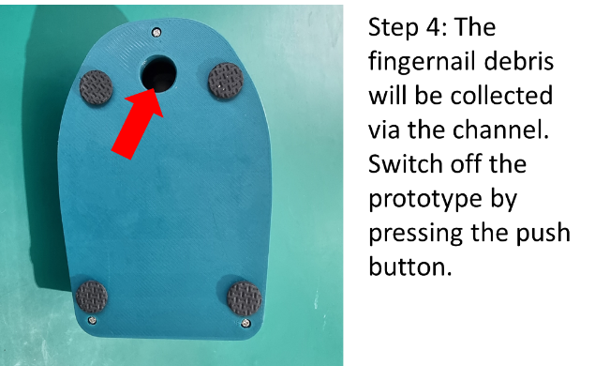

**Maintenance Manual**

Safety First – Make sure you have off the prototype before perform any maintenance.

There should be little maintenance required unless

1. Battery source is not working/ No light indication on the rechargeable battery.
2. There is degradation in trimming strength.

